# Summary

During April 2019, I downloaded Eclipse 4.11 (2019-03 release) – and tested various JSON editing plugins – and JSON Schema Validation capabilities. This document is intended to capture my findings – in preparation for submitting one or more defects on github.

# Observations

## Scenario: Using file:/d:/ URL

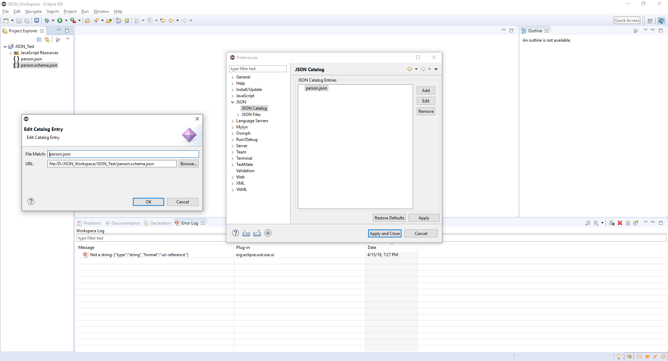

## Error: Not a string: {"type":"string","format":"uri-reference"}

org.eclipse.wst.sse.ui

Error

Mon Apr 15 19:27:38 PDT 2019

Not a string: {"type":"string","format":"uri-reference"}

java.lang.UnsupportedOperationException: Not a string: {"type":"string","format":"uri-reference"}

at org.eclipse.json.provisonnal.com.eclipsesource.json.JsonValue.asString(JsonValue.java:364)

at org.eclipse.json.provisonnal.com.eclipsesource.json.JsonObject.getString(JsonObject.java:643)

at org.eclipse.json.impl.schema.JSONSchemaNode.resolveReferences(JSONSchemaNode.java:88)

at org.eclipse.json.impl.schema.JSONSchemaNode.resolveReferences(JSONSchemaNode.java:81)

at org.eclipse.json.impl.schema.JSONSchemaNode.<init>(JSONSchemaNode.java:48)

at org.eclipse.json.impl.schema.JSONSchemaDocument.<init>(JSONSchemaDocument.java:31)

at org.eclipse.wst.json.schemaprocessor.internal.JSONSchemaProcessor.getSchema(JSONSchemaProcessor.java:57)

at org.eclipse.wst.json.core.internal.schema.SchemaProcessorRegistryReader.getSchemaDocument(SchemaProcessorRegistryReader.java:84)

at org.eclipse.wst.json.core.internal.validation.eclipse.Validator.validate(Validator.java:133)

at org.eclipse.wst.json.core.internal.validation.eclipse.Validator.validate(Validator.java:112)

at org.eclipse.wst.json.core.internal.validation.core.AbstractNestedValidator.validate(AbstractNestedValidator.java:283)

at org.eclipse.wst.json.core.internal.validation.core.AbstractNestedValidator.validateInJob(AbstractNestedValidator.java:154)

at org.eclipse.wst.json.ui.internal.validation.DelegatingSourceValidator.validate(DelegatingSourceValidator.java:239)

at org.eclipse.wst.sse.ui.internal.reconcile.validator.ReconcileStepForValidator.validate(ReconcileStepForValidator.java:252)

at org.eclipse.wst.sse.ui.internal.reconcile.validator.ReconcileStepForValidator.reconcileModel(ReconcileStepForValidator.java:210)

at org.eclipse.jface.text.reconciler.AbstractReconcileStep.reconcile(AbstractReconcileStep.java:92)

at org.eclipse.wst.sse.ui.internal.reconcile.validator.ValidatorStrategy.reconcile(ValidatorStrategy.java:270)

at org.eclipse.wst.sse.ui.internal.reconcile.DocumentRegionProcessor.process(DocumentRegionProcessor.java:323)

at org.eclipse.wst.sse.ui.internal.reconcile.StructuredRegionProcessor.process(StructuredRegionProcessor.java:260)

at org.eclipse.wst.sse.ui.internal.reconcile.DirtyRegionProcessor$BackgroundThread.run(DirtyRegionProcessor.java:694)